**Stack & Heap are different types of memories**

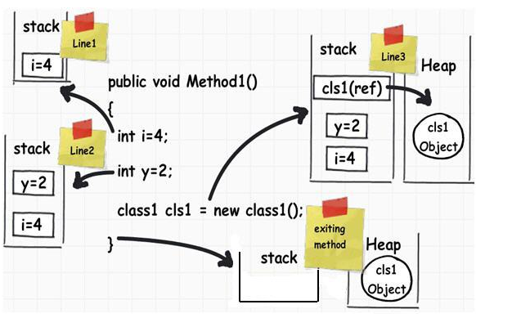

**Value types and reference types :**

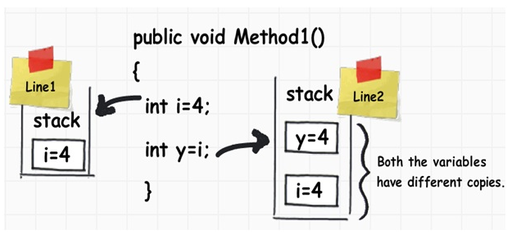

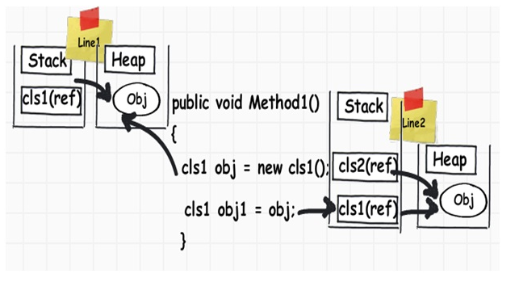

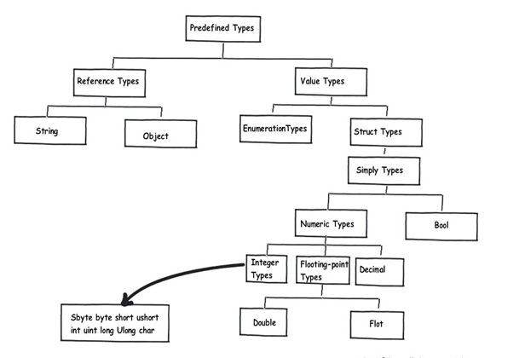

**Boxing and un-boxing :**

When the data moves from value types to reference types, it is termed ‘Boxing’ and the reverse is termed ‘UnBoxing’.

